2D graphics – Learning Aim A

unit 29

James Noble {IL} [012138]

Year 13

Contents

Purposes of 2D graphics 2

2D Graphics 2

Purposes of 2D graphics 2

Illustration purposes 2

Information purposes 3

Education Purposes 6

Graphics to assist product functionality 8

Summary 9

Characteristics of 2D digital graphics 10

Vector Graphics 10

Bitmap Graphics 11

Differences 11

Platforms 11

# Purposes of 2D graphics

## 2D Graphics

2D graphics are Computer based generation of digital images. 2D means that the graphics are only two dimensional and are therefore flat, and only work on the x and y axis compared to the x, y and z of 3D. Computer displays only show 2D, however they are capable of showing a 3D model on a 2D plane. 2

## Purposes of 2D graphics

2D graphics have several purposes. The purpose of a 2D graphic depends on the reason for its creation. This can depend on the needs of the brand or client, as they are the reason the 2D graphic is being created. 2D graphics are used to communicate to a specific target audience, depending upon the brand or client. For example, 2D graphics could be made for a user interface or a logo. They have different purposes because they are designed for different functions, as the user interface graphics are going to be used on a display, whereas a logo is going to be part of a company’s branding.

## Illustration purposes

Illustration 2D graphics are more creative compared to information or education graphics. Graphics illustrations are commonly used for logos, branding, promotional materials signage, web banners or buttons, games, Gifs, or mobile apps. Some examples of illustration graphics are shown below.



The purpose of this vector graphic is to provide an image for the brand AT&T. AT&T is a mobile service provider which operates primarily in the USA (United States of America) however it also provides worldwide coverage for customers who are on holiday. It does this by using a logo, being the blue circle. The circle could represent the world which could suggest that the brand has a worldwide effect and has worldwide coverage. As this is the face of the brand, it has to look appealing and modern as outdated graphics or unappealing graphics could turn away potential customers, because more often than not a business that looks unappealing from the outside also provides lesser products or services than alternatives. This particular logo is a vector graphic, which is useful for the brand as it means they can scale it to whatever size they want, meaning if they were to put this on a billboard that’s going to be very large, the logo won’t loose its quality which will make it consistently clear and not pixelated. The bold block colours and lack of intricate detail suggests that this is a vector graphic because vector graphics often use block colours rather than gradients and are made using objects which are unable to created photorealistic graphics. Because it’s a vector graphic, it can also be put onto other promotional products, such as stationary without losing quality. The target audience for this graphic are people who live in America (because it’s an American service) who are looking to get a mobile contract, or already are part of AT&T. The logo appeals to the target audience because its very clean looking, and make the service looks more presentable and trustworthy. The typography of the logo is full caps, bold, very squared off and is sans-serif. The font is very structured and modern, which makes the company look professional and corporate. If the font was cursive, serif or comic sans, then the logo could look unprofessional or not represent the company for what it is.

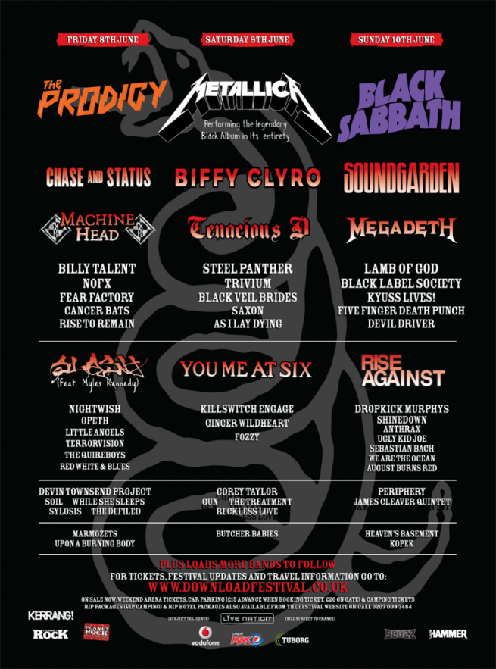 This bitmap graphic was designed as a festival line-up poster, to show people who want to go to Download festival who will be playing when they go. the fact that this image is a bitmap doesn’t impact massively on the quality of the poster, as its unlikely that it will be scaled massively to different sizes, and the image itself if usually very high resolution meaning the drop in quality when scaled up isn’t noticeable unless you really look out for it. it could also be said that a lot of the people who are going to be interested wont care about the quality of the poster and will care more about the people going, so as long as the poster is still readable it’s unlikely a lot of people will complain about the quality.

The imagery on the poster has been created to link the poster to the target audience and to represent what the festival will be like from a poster that doesn’t contain any images. For example, the snake in the background suggests the festival will be quite hardcore as snakes can be dangerous. The overall feel of the poster is quite foreboding and dark which could represent the type of music that will be played at the festival.

The font on this poster varies depending on where you look. All the names of the bands have different fonts to relate them to the band, which makes the fonts more recognisable for the target audience. Some of the fonts have a red to white gradient, some are just white and the top three bands have the colours of their band’s logo.

The design meets the target audience (people who like metal and rock) because it includes logos of the bands that people are interested in, if they are already looking at this poster. There is no defined age for the target audience of metal, as the age variety of people who like it is very wide, and both old and young people enjoy it. The bands going to this event often are very popular, so the more popular of the bands attending the event are positioned at the top of the poster with the lesser known bands at the bottom. Therefore, the logos of the better-known bands will draw in potential attendees as they would recognise the logo and therefore be more interested in the event. I think the graphic’s design meets the target audience well. As the event is a rock/metal festival, the people going are going to be more interested in dark moody colours rather than bright cheerful ones. Therefore, the colours on the poster match the target audience well, as the poster has a black background with a snake on it, with contrasting red and white text. This means the poster is easy to read but also targets its desired audience well. Including popular bands also targets the desired audience as the bands on the poster are either rock or metal orientated meaning the people who want to see those bands are also the target audience, and seeing them on the poster will draw them in.

## Information purposes

Information graphics are designed to inform the viewer on something. Whether that be an instruction they need to complete, an annual report they are reading etc. informational graphics are commonly used for instruction booklets, education, annual reports and infographics. Some examples have been shown below:

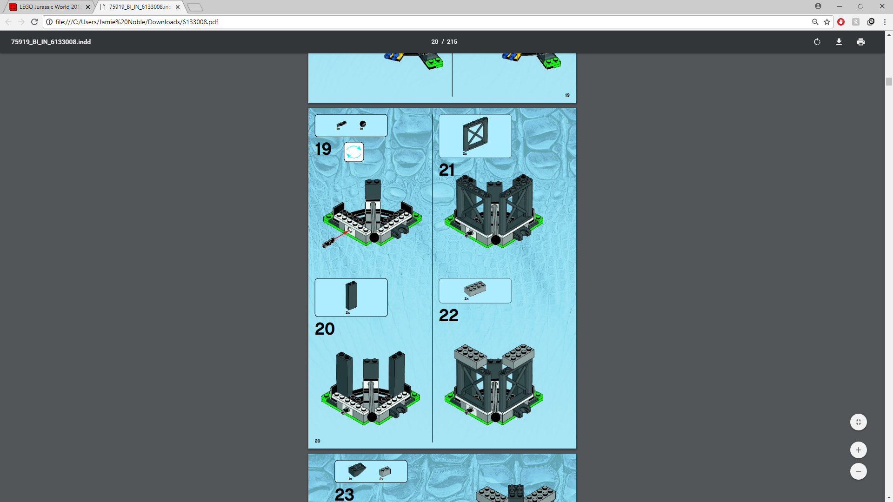this graphic was designed to show people how to construct the Lego set they have bought. Therefore, it is required to show the reader how to construct their Lego set in a clear way so that the reader doesn’t get confused. This means the target audience for this graphic is people who have bought the Lego set and are therefore interested in Lego. The graphic is a bitmap graphic, because although the graphic was designed on a computer, the images of the Lego were previously 3D modelled, and images of them could not be outputted as vector graphics and therefore must be bitmap. This is also seen because the image appears blurry and has not scaled well. The graphic communicates what you user needs to do well, and the instructions are clear. However, Lego instructions are known to sometimes be very unclear, however this one in particular is not. The instruction manual is able to fit 4 steps on this page, however for some of the larger steps they sometimes require more space on the page and therefore 4 on every page is unlikely. The page includes what parts you need for each step, as well as their model number in case you need to contact Lego support to request they send you a missing piece. This makes the instructions easier to follow as you don’t have to guess which piece to use by looking at the image. The image meets the target audience expectations as it allows them to clearly follow the instructions to build their Lego set. I don’t think the designer purposefully chose bitmap, as it was their only option due the graphics being 3d modelled. However, I think that given the chance they would choose to use vector graphics because they can be scaled meaning they could make larger images on each page without loss of quality. The colour used on this graphic is done to represent the real-life colours that the logo model would have. Therefore, all of the colours within the instruction that are on the Lego pieces are coloured to represent the real life one. The background colour is chosen so that the Lego pieces show up well on the background, as they may be harder to see on a white background. The blue chosen also isn’t available on a Lego piece meaning all Lego pieces will show up well on the background. the colours on the booklet isn’t chosen to suit a target audience, as this isn’t as necessary on an informational graphic. The imagery on this graphic is done to display the instructions that the user needs to complete. This is done by showing the before and after of the step, showing the piece of Lego they will need to complete the step, and what the step looks like what completed. The typography on this graphic is quite hard to analyse considering there is not a lot of text, and only the numbers for each step are actually text. However, the font is sans serif, bold and easy to read. this means its easy to find out which step you are on, which may be necessary if you have to ask for help etc.

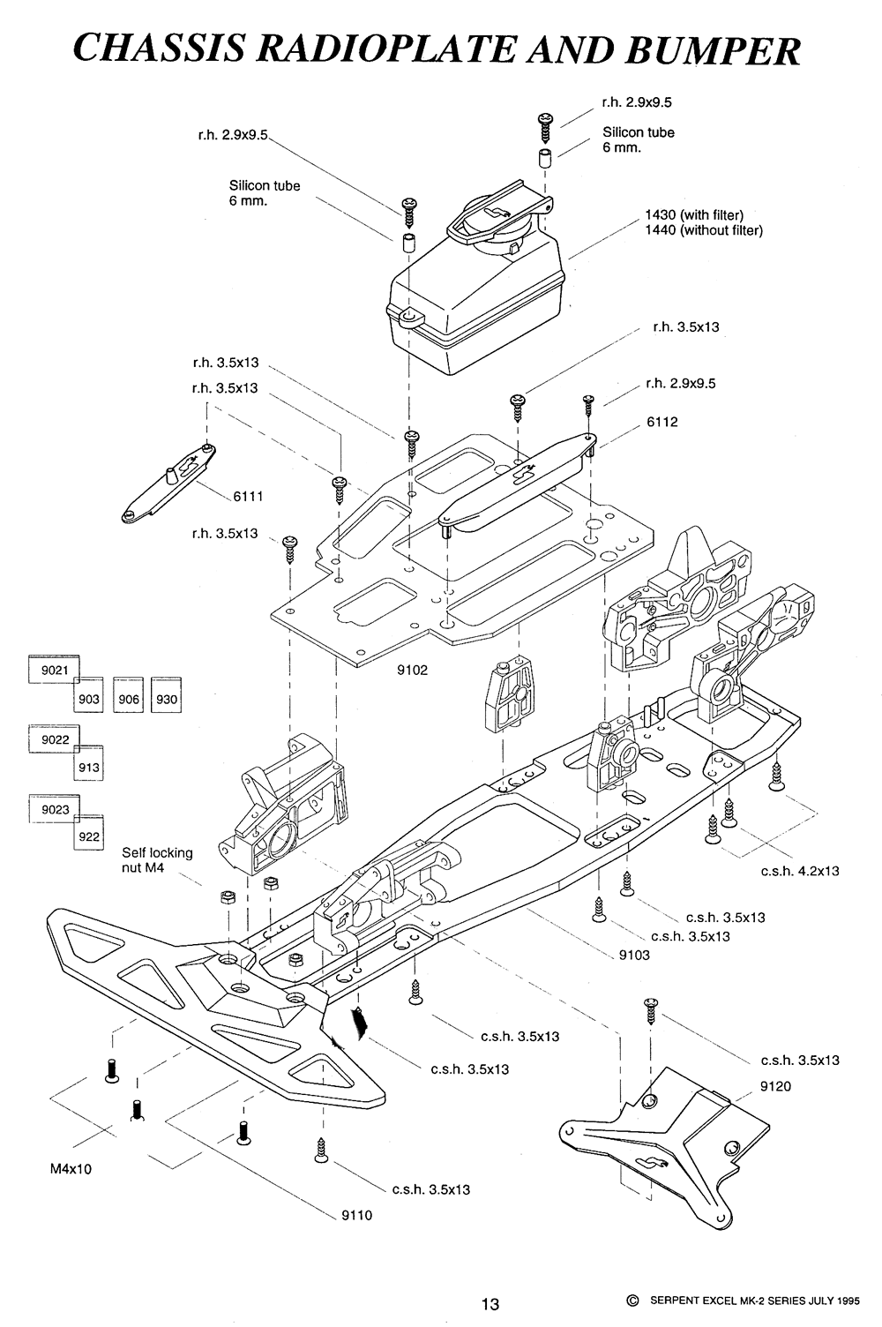this information graphic is designed to show how a component of a remote-control car fits together. This allows people to understand how its constructed in the event that the section that’s depicted needs work doing to it which would require it to be dismantled. It does this by showing each component separately and drawing lines which show how each screw connects the parts together, while showing the part number of each part so that its easy to look up and find replacements for that part. The graphic is a bitmap, which was done because the image requires large amounts of detail and was made for only one purpose meaning the ability to be scaled up and down was unnecessary. The amount of detail on the graphic gives away that it’s a bitmap as it would be nearly impossible to get that level of detail using objects and lines. There is no colour for on the graphic, and its entirely monochrome. This isn’t a problem for the graphic however, as the colour is unnecessary for the user. If we take into consideration the target audience for this graphic, which would be older people considering the complexity of the instructions, then we see that they wouldn’t care about the colour and would prefer a clearer design such as this one, compared to the Lego instructions which is for a younger audience, so the colour makes sense there. The design is very effective as it clearly shows how the different components go together making it easy to understand how to dismantle and assemble the area. this means there would be less frustration when following the guide, which could lead to the viewer trying to find another. The target audience for this graphic would be people who are interested in or have to take apart this part of a car. Therefore, this graphic meets the target audience as it clearly depicts how the part goes together making it simple for the user to follow. The typography is a mix between sans serif and serif. The heading is a serif font, with the rest of the text outlining each part being sans serif. Both fonts are easy to read and are clear to read, meaning the user won’t encounter the issue of not understanding what each part is or what it means. One issue I found is that the font for each part may be a bit small, however if this graphic was printed onto an A4 document, this wouldn’t be a problem. The imagery on the graphic is to display each part of the remote-control car part and how they connect together. There are lines which show which parts connect together and where they connect together, to the user can easily assemble the components.

## Education Purposes

Educational graphics are designed to teach the viewer something. For example, a graphic in a textbook or on a poster. Some examples are graphics used within a school textbook, on an informative poster, or on an educational website. Some examples of educational graphics are shown below:

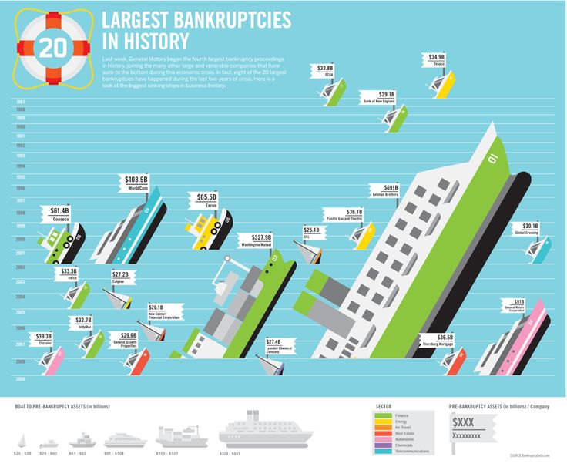

The purpose of this graphic is showing the viewer in an attractive way what the largest bankruptcies in history are. It does this by changing the size and type of boat depending on the scale of the bankruptcy, with the largest boat representing the largest bankruptcy. This theme allows the viewer to visualise the cost and then puts a tag onto the boat saying what it was and how big the bankruptcy was. This makes the graphic easier to understand as it allows the viewer to visualise the cost. This is a vector graphic, which means it can be scaled to any size without losing quality. This is especially useful on a poster as it means when it’s blown up for printing, the quality will still be high, and it won’t look blurry. the graphic looks as if it was designed to be printed out onto a poster to be put on a wall, possibly within a school where they are trying to educate you about the world. Therefore, it suits its target audience well because it is educating the viewer in an attractive manner which makes the poster nice to look at but also conveys the information clearly meaning people won’t get confused about what it trying to say. The colours used on the graphic are bold block colours. This was partly done because the graphic is a vector meaning its incredibly difficult to do anything else, but also this enhances the stylistic elements of the graphic, as the boats are quite cartoonish, so realistic colouring and shading wouldn’t fit the style. For the imagery on the graphic, as mentioned before we see the boats which represent the scale of the bankruptcy, and we see that the boats and other elements look quite cartoonish or simply. This is partly due to the graphic being a vector, and this style is common with vector graphics because they are made out of shapes and lines, so this style is quite easy to do in vector creation programs such as Illustrator. The colours of the boats also represent the industry the bankruptcy happened within, which is depicted at the bottom of the poster on a colour key. The font on this graphic is sans serif. This means the font is easy and clear to read, which is good for a poster as you don’t want people struggling to read the information on the poster or struggling to understand it, especially considering there is little detail within the text, and being able to understand what text such as the heading says is important for the success of the poster.

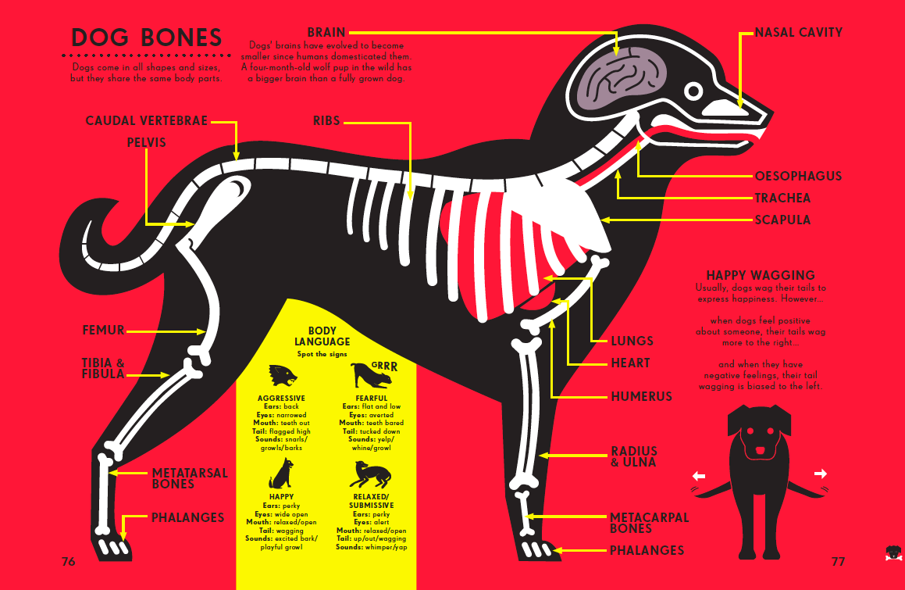

The graphic was designed to educate the viewer about the bones and body language of a dog. The graphic does this by showing a stylised cut section of a dog showing the basic outline of its bones and what they are called. It also shows sections with smaller images that describe the body language of a dog, such as what its tail wags mean or its stance. I think the graphic is targeted more towards children as its very stylised and quite simplistic as to not overwhelm them with knowledge. Older audiences would find this graphic to be a bit lacklustre in terms of the amount of information or the detail and would most likely want to see something more detailed. I think it conveys its content effectively, as the font is easy to read and contrasts well with the background, and the graphic quite clearly depicts the bones within a dog without using a photorealistic graphic of a dog, as seeing the bones of a real dog could end up being quite traumatic for the viewer, especially if the viewers are quite young. The bright red background draws the viewers attention towards the graphic but doesn’t take away from the dog in the middle as it uses contrasting colours to show up well. For example, the main outline of the dog is in black, with the bones in while and organs red or dark purple. All of these colours contrast well together and don’t blend making them stand out clearly. The dog appears to have similarities with a Labrador, which is one of the most popular dogs in the world, meaning a higher percentage of people will understand that what applies in this poster would also apply to their pet if they owned a dog. Arrows are used to point to the different bones from their tags to show what each one is called. This graphic is clearly a vector graphic. This is because it uses bold colours with no gradients, and all of the lines are very smooth with a lack of detail. The dog does not look photo realistic as this would require it to be a bitmap graphic. I think the maker created it using vector graphics so it looked stylised and visually attractive, however I think they also did this so the graphic can be scaled to any size allowing it to be on any size of poster giving it more flexibility when it came to printing, such as being able to fill an entire billboard without losing quality or being able to go to go to an a4 poster and still be readable. I think the graphic does what it was designed to do well and meets the target audience’s expectations well, as its able to educate people about the bones within a dog, as well as relate to dog owners in an attractive and clear way. As said before, the font or typography is easy to read and stands out well on the background. this is important to the success of the graphic and means the audience wont struggle to understand what they are being shown. The font is sans serif which makes the poster look more modern and up to date.

## Graphics to assist product functionality

These graphics are designed to in someway assist a product in performing its purpose. this may include a game or DVD interface, mobile apps and their graphics, web buttons and banners or operating system UI graphics. Some examples of graphics to assist product functionality have been shown below:

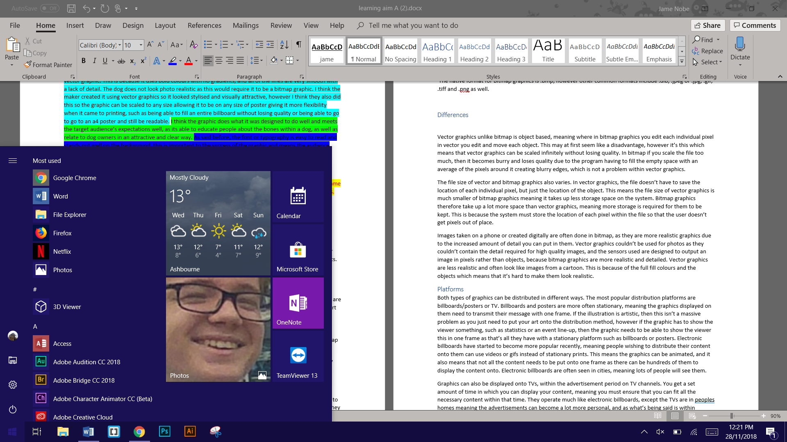One example of graphics to assist product functionality would be the windows UI. The product in this case would be the windows operating system. The windows UI assists the product functionality because it allows the user to interact with the different elements of the PC, such as launching apps or changing settings. In this case, the graphic in question is the windows start menu, in which you are able to access files, most used apps and other apps, as well as go into settings and restart or turn off the PC. The colour of the graphics here are interchangeable. The background colour, which in this case is dark blue, can be changed depending on what the user wants it to be. The colours on all the icons depends on what the icon for the application is, however the icons are separate graphics compared to the windows bar, as they are dependent on what the user has installed. The graphics for the windows starts bar are vector graphics. I know this because the windows start bar is scaled relative to the resolution of the display, or whether the user wants it to be bigger and smaller. The graphic is a vector because it means when it scaled up or on a higher resolution display, the graphic doesn’t lose detail, and doesn’t become fuzzy. For example, if it was a bitmap graphic and was scaled up, details such as the power button would become fuzzy and loose detail. The target audience for these graphics are anyone who use the windows operating system, which is 81.76% of all desktop or laptop users. These graphics are often overlooked by the audience, even if they use them every day. Because the target audience is so wide, its important the graphics are simple and easy to use for them, because windows doesn’t want users to move towards other operating systems such as Linux, which has more customisation, or Mac OS, which is easier to use. The imagery of the graphics is very simplistic. Most of the UI for windows consists of squares or rectangles, with the icons for settings and the power button just being simple circle-based icons. The UI looks very good even though its very simplistic, which makes it more appealing to use. The typography used on the graphic by default is a sans serif font, which switches between black or white depending on the background colour. The font is designed to be easy to read, so that all users can understand what it says. As windows is used in countries other than English speakers, the font is able to change language by using the settings. The size of the font can also be changed if the user has bad eyesight.

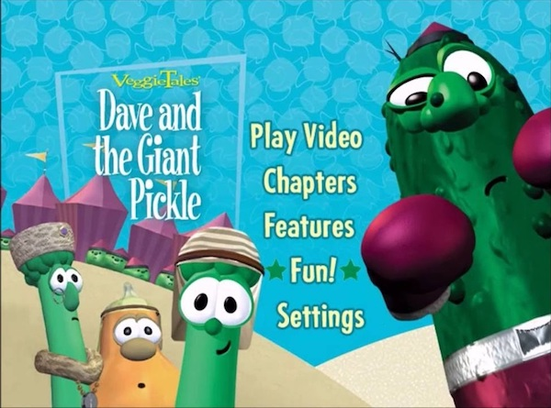

This graphic is a DVD menu interface, designed to allow the user to access the different features available on the DVD. This includes settings, playing the video or accessing the various chapters of the video. The colour shown are very cartoonish, bright and childish colours, such as blue, green and purple. The colour of the background stands out well compared to the other colours on the screen, mainly the font for the title of the video and the text on the menu. The background colour actually has a texture, which gives the background some detail and makes the graphic as a whole more interesting to look at. This graphic is a bitmap graphic. We can see this because the characters have got a lot of detail and shading, which isn’t possible or as easy within vector graphics, and is only really possible with bitmap. Especially considering that the characters in question are screenshots of 3D models, which cannot be displayed in anything other than bitmap, as a screenshot will record the pixels and not the shapes. The target audience for this graphic is children. This is quite obvious for a number of reasons, mainly that the video in question is a children’s program, but also the graphics are clearly quite childish/cartoonish, which wouldn’t be appealing to older audiences. The target audience isn’t likely to actually use the interface however, as they will most likely be too young to either be trusted to control the TV or are too young to know how. Therefore, although the target audience appears like its for a younger audience, the younger audience wont actually be the ones using it. this is why advanced features such as settings are included. The reason the graphics are still childish is because the younger audience will still be in the room while on this screen and having a screen before the program, they are watching that is more adult like might make them loose interest before the program has even started. As talked about within the target audience section, the imagery within this graphic is quite cartoonish and childish to appeal to the target audience. It has done this by showing characters that will be in the program. What is presumably the main characters are shown on this menu to introduce the audience to them before the program has even started. The typography used within this graphic is also adjusted from what we would normally see to apply to a younger audience. The font is easy to read, and very childish which relates to both the audience and the content within the video. Although the font is childish, as said before its unlikely that the audience would interact with it as they may be too young, so its mainly so that the children watching don’t loose interest because the graphic doesn’t look like it would be fun for them. all the font used stands out well against the background, so its not hard to distinguish it from said background, and the font used for the name of the show is most likely the font used for the logo of the show, to relate it to other products within the same company.

## Summary

Where illustration graphics are used more for brand image, digital presence, promotional material, etc, information graphics are more based around informing the viewer on a particular subject. Illustration graphics may be used alongside information graphics, such as on the cover of an instruction booklet, they aren’t able to portray knowledge like information graphics can. for example, the AT&T logo doesn’t tell you anything about the company, as its not designed to. Its only purpose is brand identity. This means the design reflects this, as the design needs to be eye catching which an information graphic wouldn’t need to be, because people don’t care if its eye catching because if they are going to read it, they’re going to read it regardless of whether it looks nice or not. Illustration graphics are often vectoring especially when them for-brand identity because vector graphics can be scaled for different purposes such as being on a poster or a billboard. Information graphics on the other hand are often bitmap because it allows greater detail which is especially important for something like a instructional booklet. The Lego instruction booklet tells the user something, in this case how to build a Lego set, but it would be useless for brand identity as it isn’t used for showing off the company, for putting on boxes or stationary etc, which is what illustration graphics are good at. Illustration graphics tend to be more creative and imaginative to catch the eye of the target audience, whereas information graphics tent to be clearer and simpler to make them easier to understand. When making illustration graphics the target audience must be taken into consideration, because in order to make something eye catching you need to know who you are trying to make it eye catching for. For example, if you’re a makeup brand, then a huge billboard would be eye catching to your target audience which would be women, but it wouldn’t be eye catching to any men walking past it. information graphics also need to apply to the target audience, but not as much because if someone wants to know about something, then it doesn’t matter how eye catching it is, if people want to know about that subject then they’re going to read about it regardless.

Educational graphics however are similar in a way to information graphics as they still hold information. However, information graphics tell you something such as instructions, whereas educational graphics teach something to you and explain a particular subject, such as a diagram of a skeleton. Much like information graphics, education graphics would be useless for brand identity, which is what illustration graphics are good at. Educational graphics aren’t specifically always vector or bitmap, as there are examples of both educational vector and bitmap graphics. However, vector graphics are ideal for educational use because they can be scaled up or down for posters and or school books. However, as vector graphics can’t hold a lot of small details, it means they are useless for images. This is why images are always bitmaps for educational uses because for educational use you need to be teaching the target audience in detail, and vector graphics don’t have the same detail and would therefore be worse for teaching in this use case. Imagery is more important for educational uses because its easier to teach if you have some form of graphic because it means you can show the audience what you are trying to teach them, which may also make them more interested in what you are teaching. Whereas with information graphics, you are showing how something is completed or what has happened, not teaching them on it but just telling them. Information graphics presume the audience already has some form or prior knowledge, and if its an instruction booklet then the audience will have the parts for what they are trying to construct. This means they don’t need extreme detailing on each part for the instruction booklet, and they don’t need telling how to construct each part, but they need to be told where each part goes and that’s it. this means imagery isn’t as important as long as the graphic is clear.

Graphics to assist product functionality are completely different from all of the other three, however elements from the other three can be seen in these graphics. For example, graphics on operating systems make up what they look like. Windows looks the same on every computer with it installed, apart from small changes such as colour. This means the look of windows could actually be used as a brand identity for the operating system, which means it takes elements from illustration graphics. However, its also completely different from the other types of graphics, because unlike the others, these graphics (graphics that assist product functionality) actually have to be interacted with, such as being clicked or moved. This means it needs multiple states and animations, such as when you click on a button it looks like it moves down. Illustration, information and education graphics don’t get interacted with and therefore don’t need interactive elements like graphics that assist product functionality.

# Characteristics of 2D digital graphics

## Vector Graphics

Vector graphics are based around objects, meaning that they don’t take up as much space, as the computer doesn’t have to store image which take up space and only has to store the objects that make up the graphics. Each object can be edited while creating the graphics. Vector graphics are often less detailed than bitmap meaning they take up less space. However, this doesn’t mean the quality of vector graphics are lower, it means that the detailing the creator is able to put into the graphics is much less. Vector graphics don’t lose quality as they are scaled up, as the objects get larger in size and don’t pixilate. This means that an a4 sized vector graphic could be digitally scaled up to the size of a building and it wouldn’t lose quality. The graphics are less realistic and are more cartoony, meaning they are frequently used in children’s books as they suit the art style, as well as in advertisements, especially if the advert will be distributed to different formats as you wouldn’t have to completely remake a magazine advert for a billboard, because if it is created using vector graphics then it can just be scaled up without loss of quality. Illustrator is a popular software for creating vector graphics and is in the adobe software suit. Vector graphics consist of flat fill colours rather than Bitmap which consists of gradients, however bitmap can also have flat fill colours.

The native format that software can read for vector graphics is .svg, however vector graphics are commonly stored as .cgm, .odg, .eps and .xml as well.

## Bitmap Graphics

Bitmap graphics are pixel based unlike vector which is object based. Therefore, you can edit the individual pixels which cannot be don’t with vector graphics. The file size for bitmap is often large, as computers have to store the details of the file as individual pixels. Unlike vector graphics, bitmap graphics loose quality when they are enlarged. This is because when you enlarge an image, you are separating each pixel out more. Where this would usually create blank spaces, the program tries to either fill the blank space with black, white or an average of the colours of the pixels around the blank space. This reduces the quality because it blurs any sharp edges. Bitmap graphics are more realistic because they are normally photos that have been taken. This means that the pixels are organised to look like the photo that the user took. Photoshop is commonly used for editing and creating Bitmap graphics. This is in the adobe suit, which costs quite a lot, meaning that the most common bitmap graphic software is actually Microsoft paint, as it’s included with every version of windows currently being sold. Bitmap graphics also have gradients and depth which vector does not.

The native format for Bitmap graphics is .bmp, however other common formats include .dib, .jpeg or .jpg, .gif, .tiff and .png as well.

## Differences

Vector graphics unlike bitmap is object based, meaning where in bitmap graphics you edit each individual pixel in vector you edit and move each object. This may at first seem like a disadvantage, however it’s this which means that vector graphics can be scaled infinitely without losing quality. In bitmap if you scale the file too much, then it becomes burry and loses quality due to the program having to fill the empty space with an average of the pixels around it creating blurry edges, which is not a problem within vector graphics.

The file size of vector and bitmap graphics also varies. In vector graphics, the file doesn’t have to save the location of each individual pixel, but just the location of the object. This means the file size of vector graphics is much smaller of bitmap graphics meaning it takes up less storage space on the system. Bitmap graphics therefore take up a lot more space than vector graphics, meaning more storage is required for them to be kept. This is because the system must store the location of each pixel within the file so that the user doesn’t get pixels out of place.

Images taken on a phone or created digitally are often done in bitmap, as they are more realistic graphics due to the increased amount of detail you can put in them. Vector graphics couldn’t be used for photos as they couldn’t contain the detail required for high quality images, and the sensors used are designed to output an image in pixels rather than objects, because bitmap graphics are more realistic and detailed. Vector graphics are less realistic and often look like images from a cartoon. This is because of the full fill colours and the objects which means that it’s hard to make them look realistic.

## Platforms

Both types of graphics can be distributed in different ways. The most popular distribution platforms are billboards/posters or TV. Billboards and posters are more often stationary, meaning the graphics displayed on them need to transmit their message with one frame. If the illustration is artistic, then this isn’t a massive problem as you just need to put your art onto the distribution method, however if the graphic has to show the viewer something, such as statistics or an event line-up, then the graphic needs to be able to show the viewer this in one frame as that’s all they have with a stationary platform such as billboards or posters. Electronic billboards have started to become more popular recently, meaning people wishing to distribute their content onto them can use videos or gifs instead of stationary prints. This means the graphics can be animated, and it also means that not all the content needs to be put onto one frame as there can be hundreds of them to display the content onto. Electronic billboards are often seen in cities, meaning lots of people will see them.

Graphics can also be displayed onto TVs, within the advertisement period on TV channels. You get a set amount of time in which you can display your content, meaning you must ensure that you can fit all the necessary content within that time. They operate much like electronic billboards, except the TVs are in people’s homes meaning the advertisements can become a lot more personal, and as what’s being said is within someone’s home the viewer might equate it to a friend recommending something to them which might make them more likely to attend the event you are hosting, or to buy the product you are trying to sell.